CS 255 System Design Document

UML Diagrams

UML Use Case Diagram

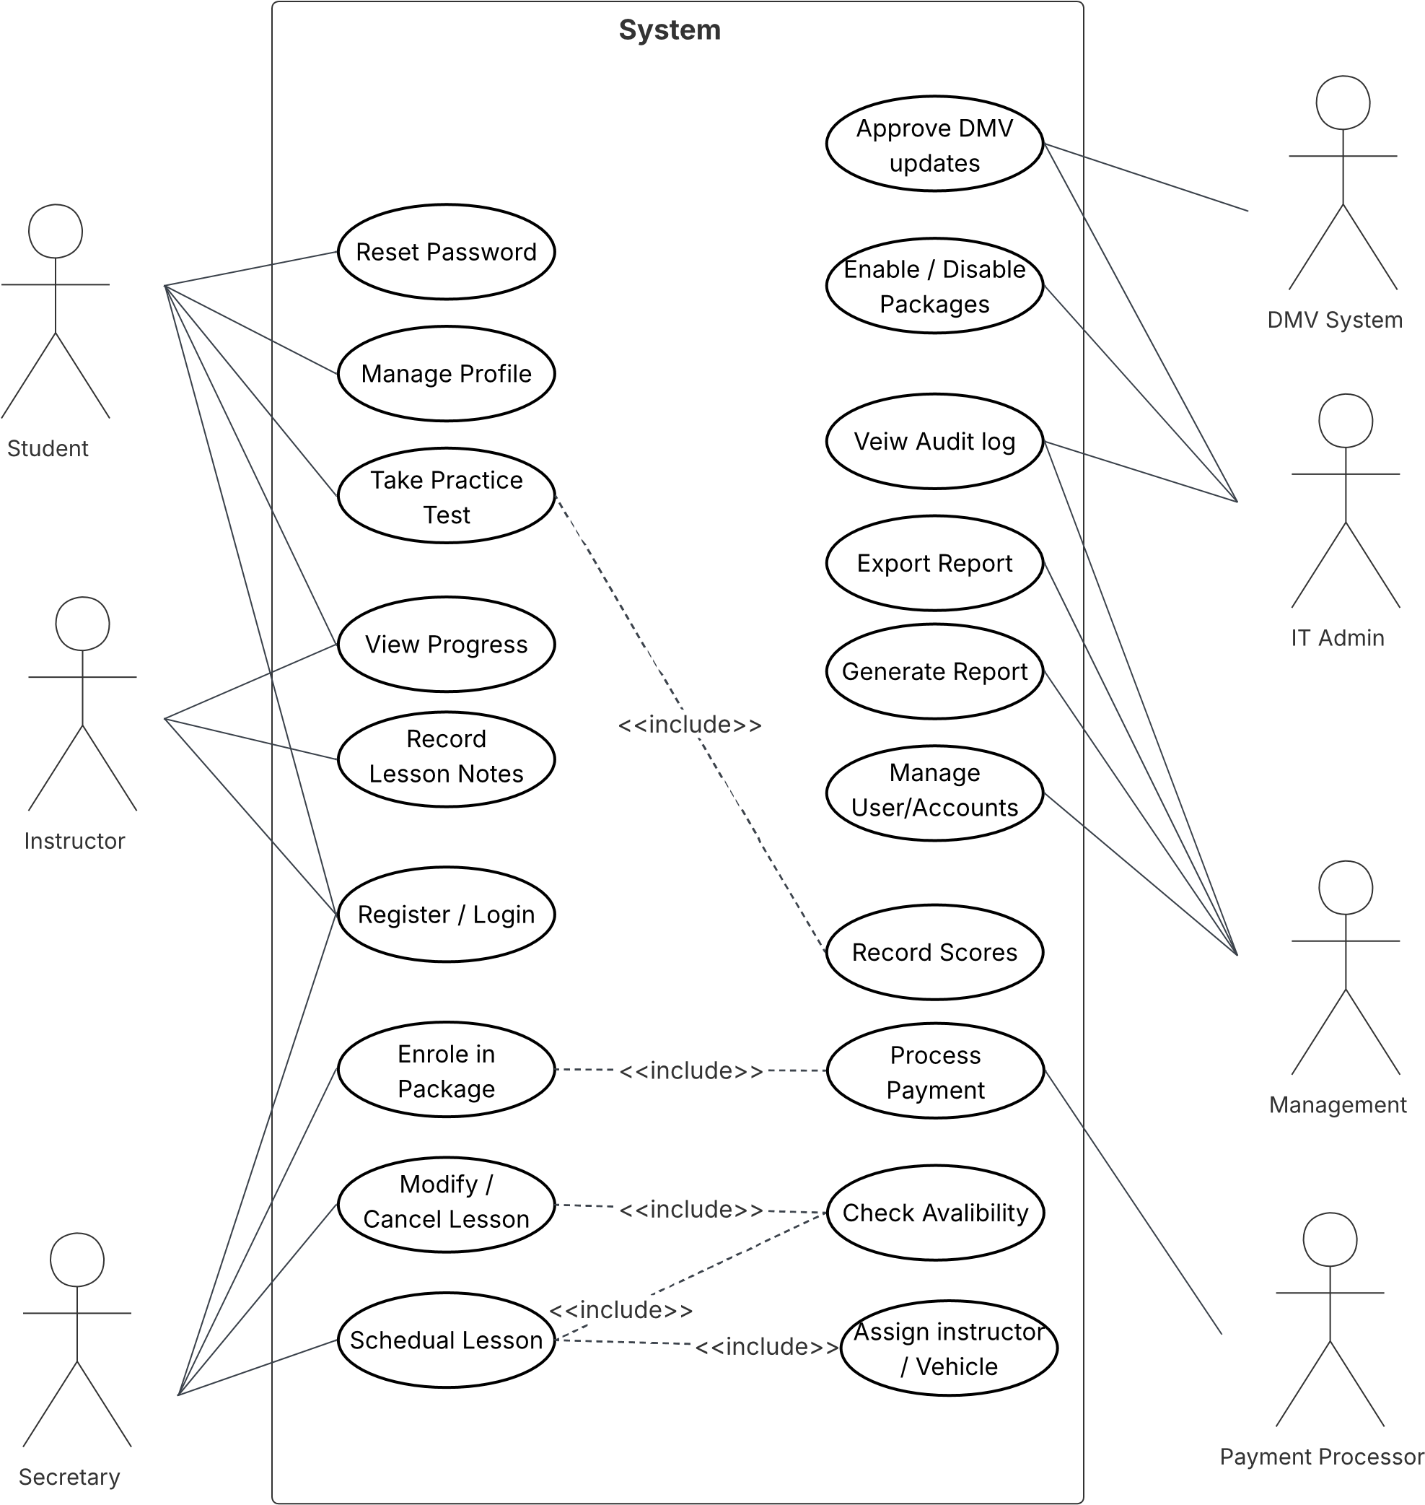

UML Activity Diagrams
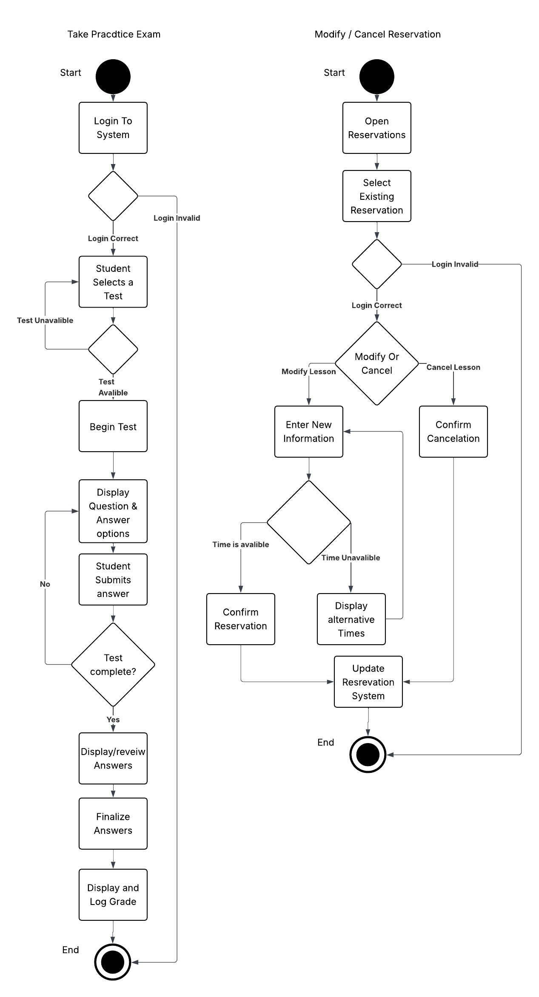

UML Sequence Diagram
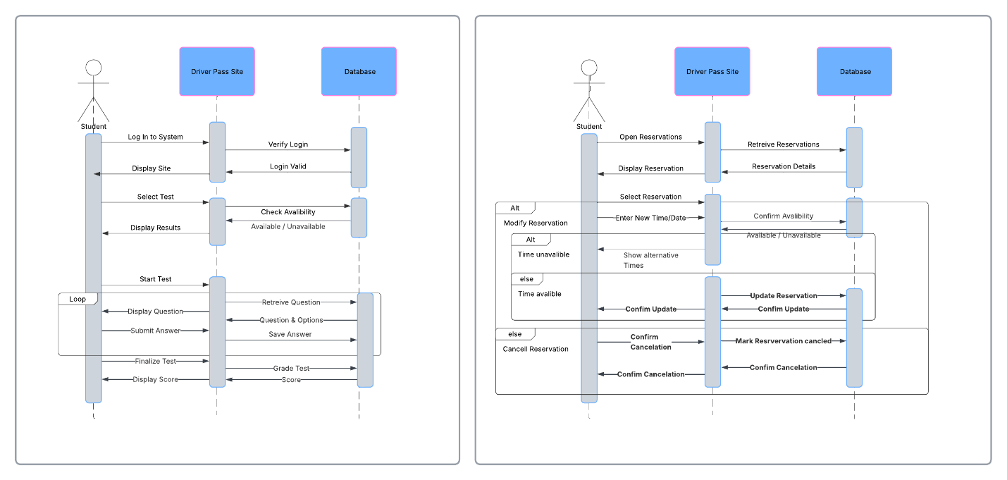

UML Class Diagram
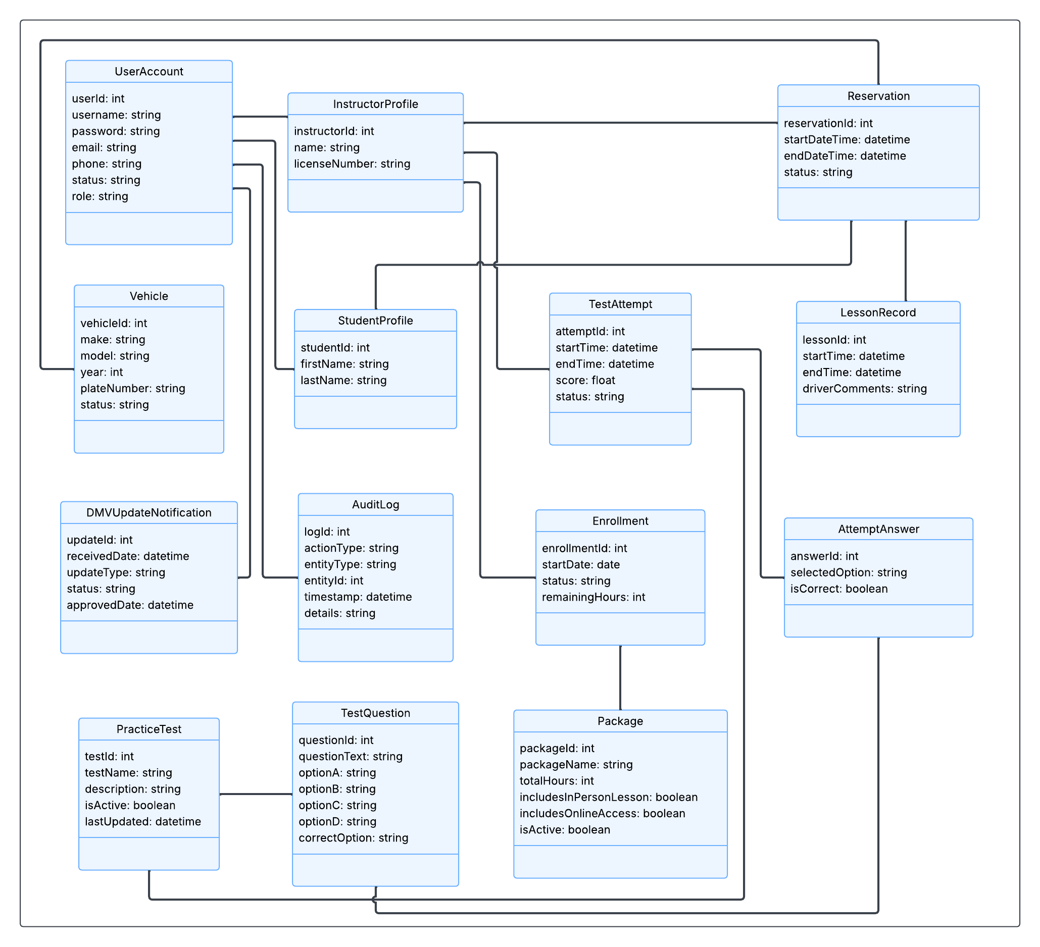

Technical Requirements
Hardware Requirements:
- The system shall be hosted in a cloud-based server to support continuous web access and reduce local maintenance requirements.
- The hosting environment shall provide sufficient power (CPU/RAM) resources to support multiple concurrent student testing and reservation scheduling without performance degradation
- The hosting environment shall provide scalable storage for persistent data including user profiles, reservations, records of lessons, practice test attempts and audit logs.
- End users shall require access to a desktop or mobile device capable of running a modern web browser and maintaining an internet connection.
Software Requirements
- The system shall be implemented as a web-based application accessible through modern browsers(Chrome, Edge, Firefox, Safari) with a layout that is responsive for both desktop and mobile browser use.
- The system shall use a database management system (MySQL) to store and connect core entities from the class diagram including:
  - User accounts & Roles
  - User Profiles
  - Packages and enrollment
  - Reservations, vehicles and lesson records
  - Practice tests, questions, attempts and answers
  - Audit logs and dmv update notifications
- The system shall support the generation and export of reports for management review and offline analysis
Tool and Infrastructure requirements
- The system shall be deployed with a cloud infrastructure model in mind that supports load handling, automated backups, and centralized monitoring for visibility and troubleshooting.
- The system shall use a secure authentication approach for role based access, secure password storage, account lockout after repeated attempts, and a secure workflow for password resets.
- The system shall use encrypyted communication for all client-server traffic
- The system shall include an audit logging mechanism for critical events, including creation, modification and deletion of reservations and administrative actions.
External integration and data requirements
- The system shall support an semi-automated DMV update
  - DMV updates are received as notifications or update packages
  - Updates are stored in a pending state
  - An Admin / IT role user reveiews and approves the updates before they are applied to practice tests or instructional content
  - Update actions are recorded in the audit log for traceability
Security and data protections
- The system shall protect sensitive information using encryption in transit, and secure storage practices.
- Payment information will be handled through a compliant approach (such as a third party processor) to reduce exposure of card data.
- Access to administrative features shall be restricted to authorized roles.

